**Auto-WCEBleedGen Challenge Version V2**

**Team Name :** failed wizards

**Team member names and affiliation :**

|  |  |
| --- | --- |
| **Name** | **Affiliation** |
| Sasidhar Alavala | MS(R), IIT Tirupati |
| Anil Kumar V | BTech, IIT Tirupati |
| Aparnamala K | BTech, IIT Tirupati |
| Dr. Subrahmanyam Gorthi | Assoc. Professor, IIT Tirupati |

**Contact number :** 8500241025

**Email address :** [ansr2510@gmail.com](mailto:ansr2510@gmail.com)

**Brief write up about the pipeline :**

This pipeline leverages three state-of-the-art models: Swin Transformer for classification, RT-DETR for detection and SwinUNETR for segmentation. The pipeline begins with a series of image preprocessing steps, including colour space conversion to LAB, CLAHE (Contrast Limited Adaptive Histogram Equalization), and Gaussian blur to enhance image features.

These preprocessing steps are applied to both training and validation data.

For training data, various data augmentations are incorporated to improve model robustness and generalization. These augmentations include random horizontal and vertical flips, random rotations, Gaussian blurring, random affine transformations, random perspective distortions, and MixUp.

**Figure of the development pipeline :**

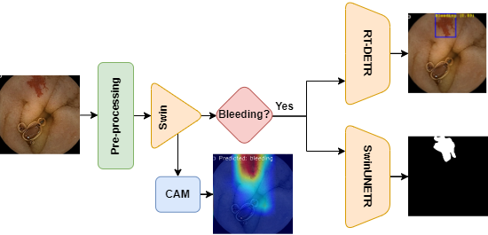

**Achieved results:**

**Classification**

|  |  |  |  |
| --- | --- | --- | --- |
| **Dataset** | **Accuracy** | **Recall** | **F1 Score** |
| **Validation** | 0.98 | 0.98 | 0.98 |
| **Test 1** | 0.80 | 0.80 | 0.89 |
| **Test 2** | 0.88 | 0.83 | 0.89 |

**Detection**

|  |  |
| --- | --- |
| **Dataset** | **AP@IoU=0.50** |
| **Validation** | 67.0 |
| **Test 1** | 58.0 |
| **Test 2** | 70.0 |

**Segmentation**

|  |  |  |
| --- | --- | --- |
| **Dataset** | **IoU** | **Dice Score** |
| **Validation** | 0.48 | 0.62 |
| **Test 1** | 0.23 | 0.34 |
| **Test 2** | 0.43 | 0.58 |

**Plots: Validation**

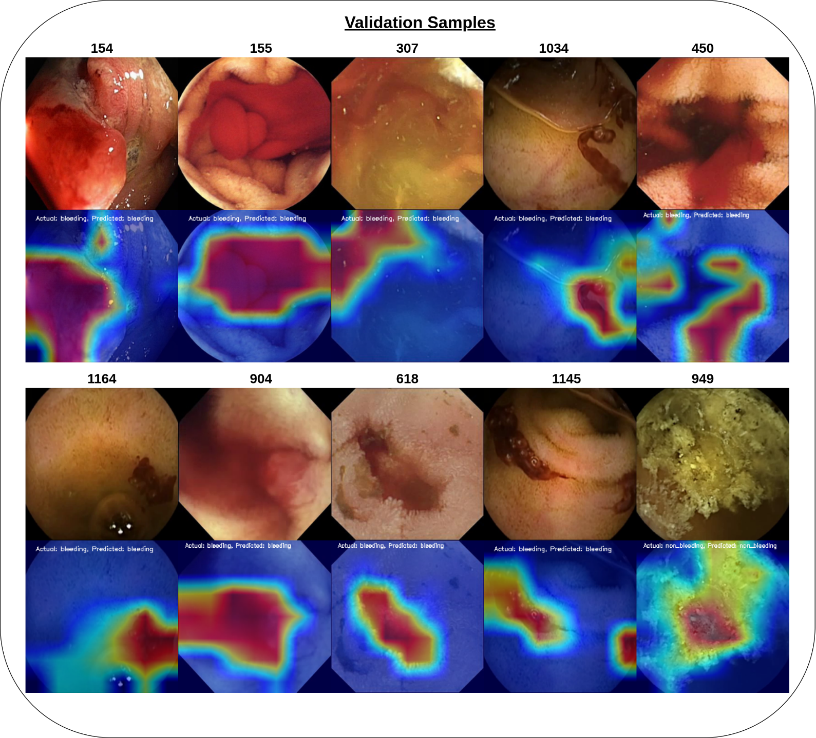

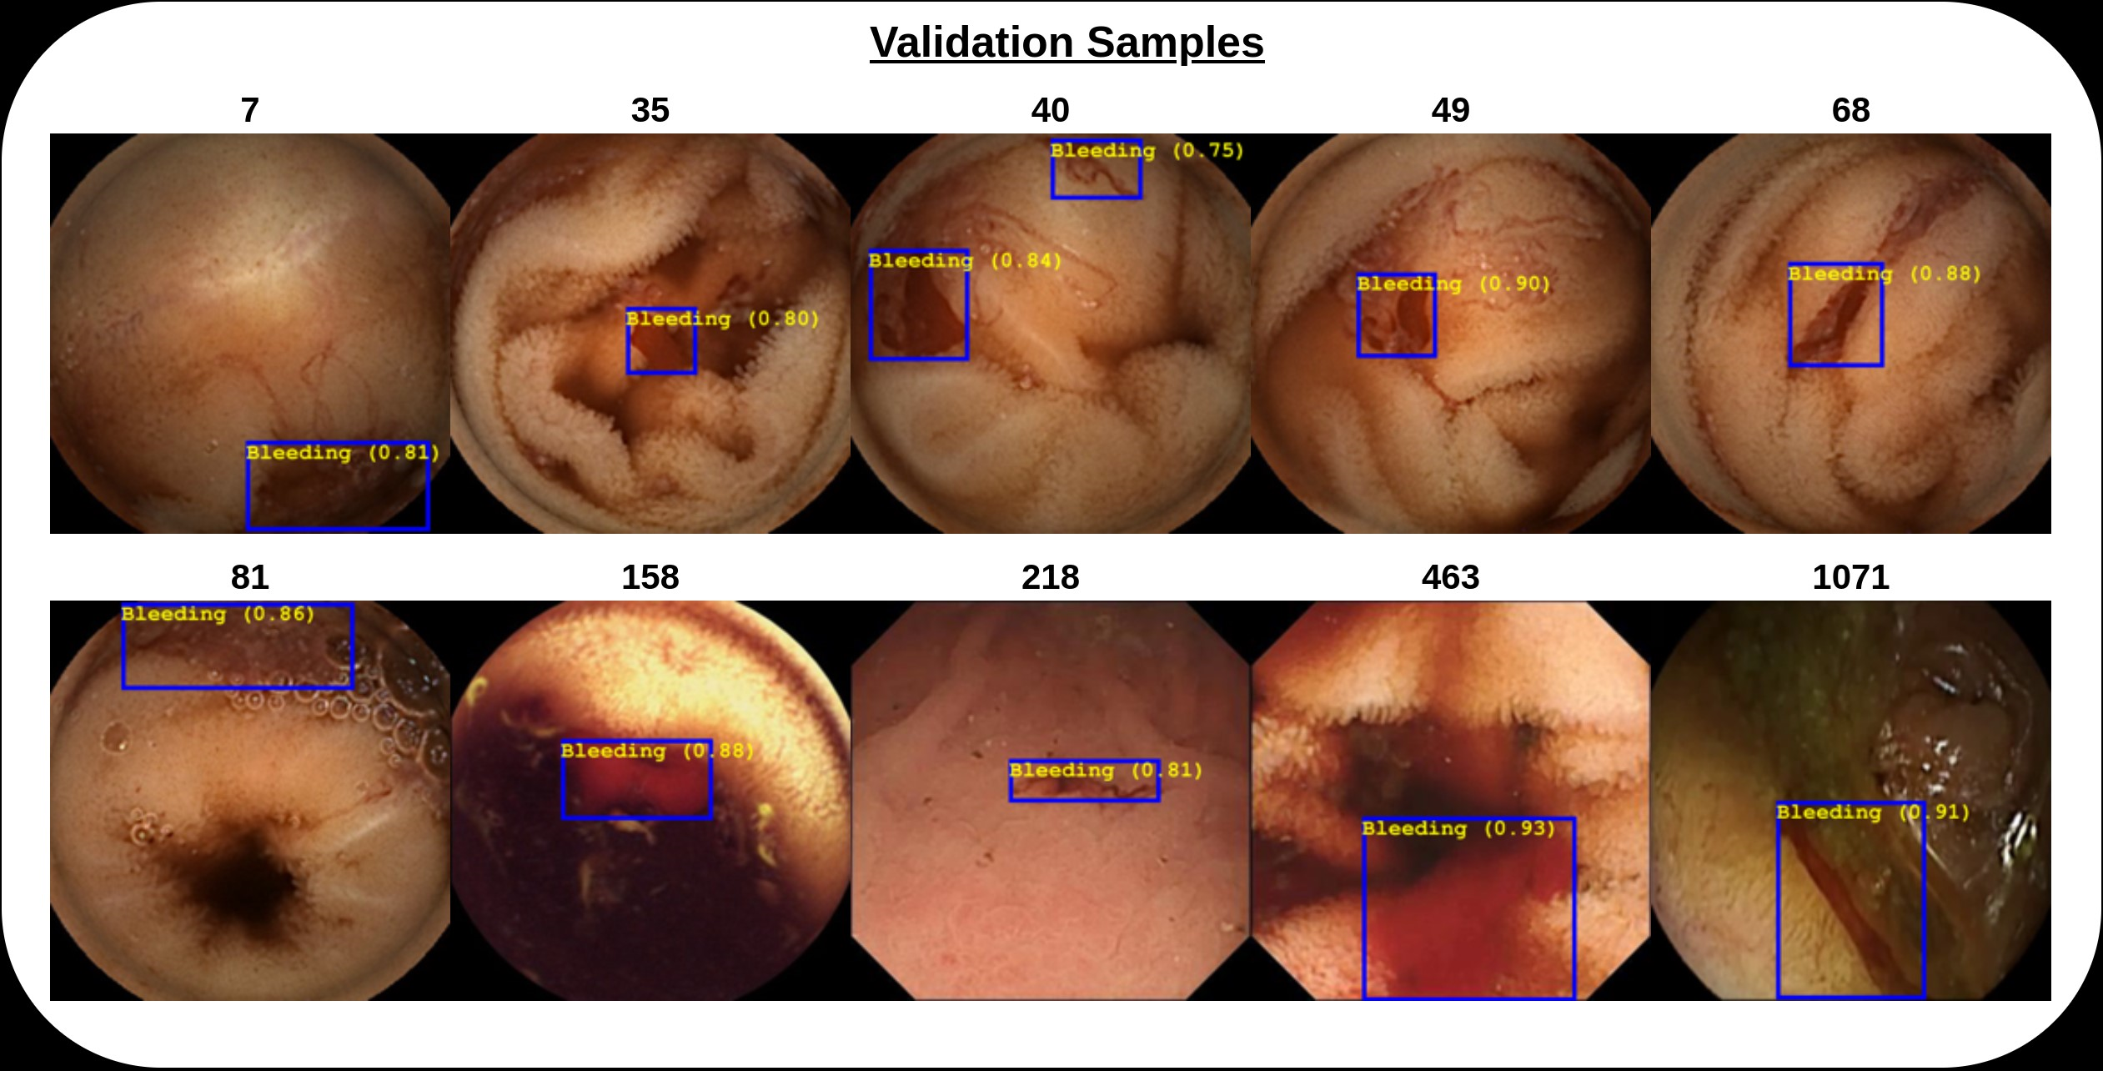

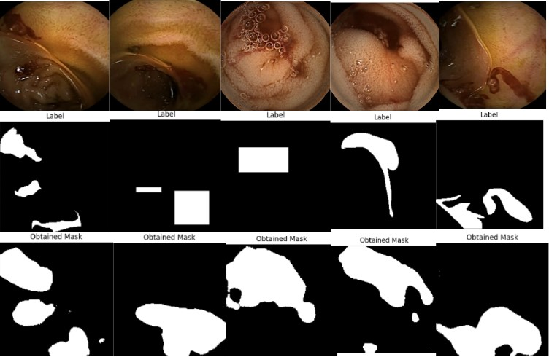

**Plots: Test 1**

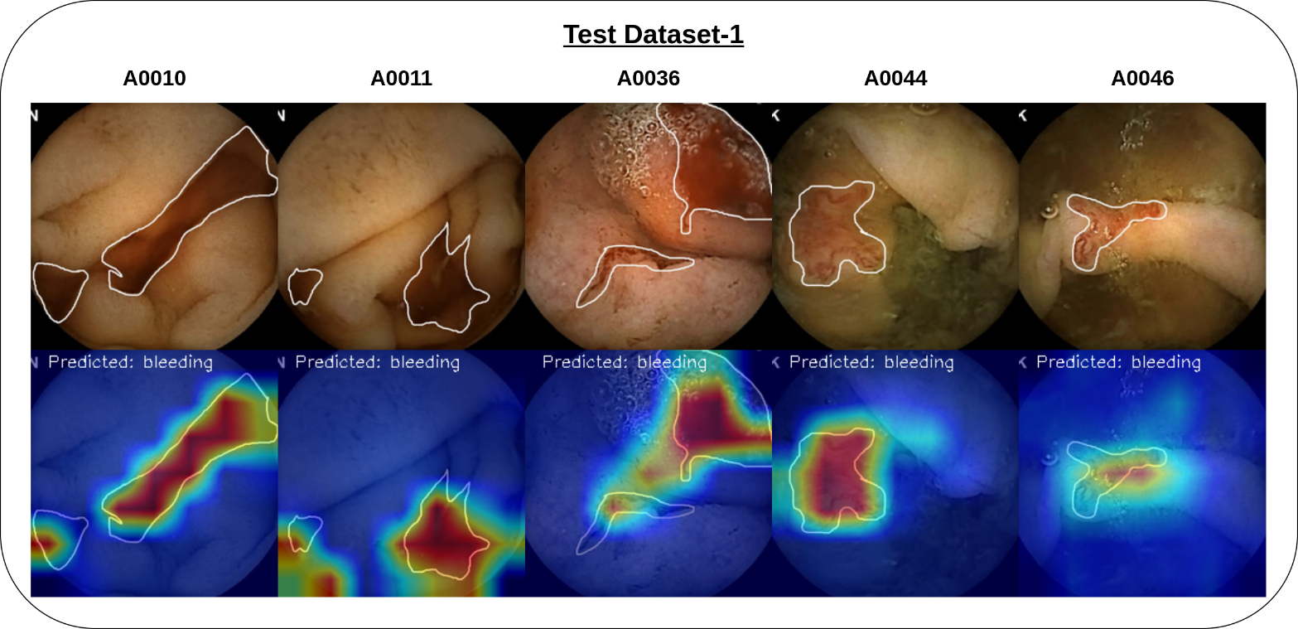

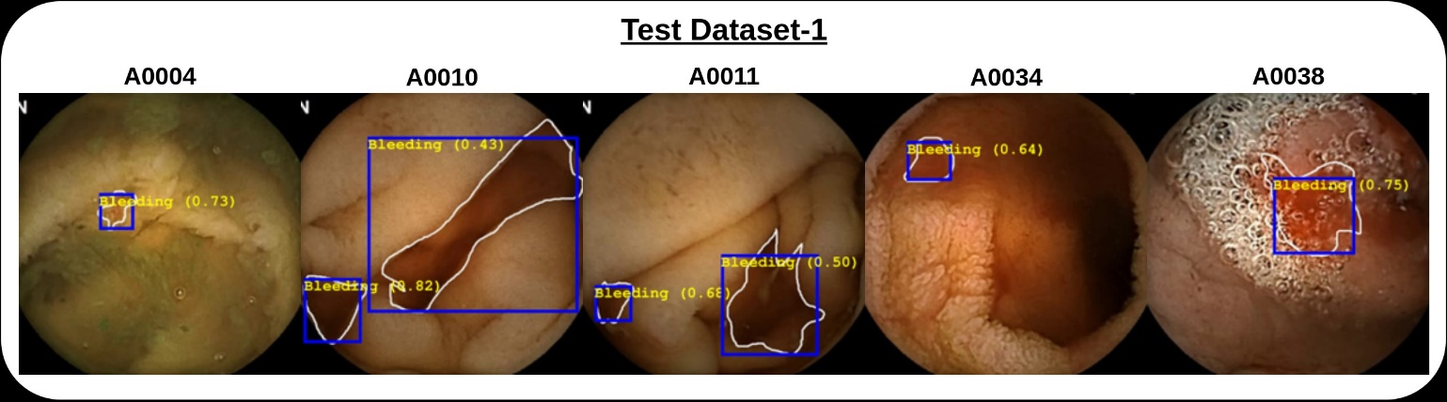

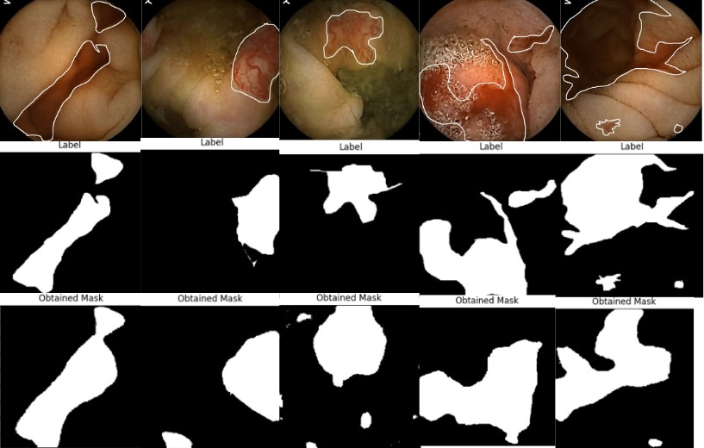

**Plots: Test 2**

